This is the author’s accepted manuscript. This version is under copyright and should not be considered the final published version. For citation purposes, please refer to:
Finger-Bou, R., & Muñoz, C. (2024). The effects of textual enhancement on young learners’ attention and vocabulary acquisition through captioned cartoons. In C. Muñoz & I. Miralpeix (Eds.), Audiovisual input and second language learning (pp. 48–73). John Benjamins. https://doi.org/10.1075/lllt.61.03fin

The effects of textual enhancement on young learners’ attention and vocabulary acquisition through captioned cartoons

Rebeca Finger-Bou (Universitat de Barcelona)
Carmen Muñoz (Universitat de Barcelona)

Abstract
This study aimed to analyse the effects of textual enhancement of captions on vocabulary acquisition by 17 L1-Spanish/Catalan primary school learners of English in fifth grade. Participants watched 11 episodes of a children’s television series. They were divided into two groups: one watched the videos with regular captions, and one with enhanced captions, where target words were bolded and highlighted in yellow. We assessed vocabulary gains through pre- and post-tests that tapped into form recall and form recognition. Results showed higher learning in the enhanced captions group, particularly in terms of form recognition. Additionally, an eye-tracking analysis showed that the enhanced-captions group had longer fixation durations initially, but the difference disappeared by the end of the intervention.
Key words: captions, textual enhancement, primary school learners, vocabulary acquisition, eye-tracking.

1. Introduction

Researchers agree that the quantity, quality and intensity of exposure to a second language (L2) have a significant impact on foreign language learning (Muñoz, 2022). The increasing access to audiovisual resources, including television, streaming services, and social media, has transformed the way we consume information, communicate with others, and ultimately, the way we learn languages. In that sense, language learners are certainly motivated to watch television programs in the L2, as has been documented in surveys on language learners’ engagement with the L2 outside of the educational setting (Peters & Muñoz, 2020).
Multimodal input, as a fusion of visual elements, auditory verbal input, and written verbal information (such as captions in the language of the audio [L2] or subtitles in the viewer’s language [L1]), has the potential to enhance language learning (Muñoz, 2022). This occurs when both visual and verbal channels are activated simultaneously. According to Mayer’s (2009) Cognitive Theory of Multimedia Learning, the simultaneous reception of information through separate channels can increase our limited attentional capacities. This has been attributed to the complementary nature of the three input sources (audio, visual, and caption text), which collectively support the learning process from audiovisual input by effectively disseminating information (Vanderplank, 2016). The auditory component allows learners to associate spoken words with their correct pronunciation, the visual element aids in recognizing contextual clues and facial expressions, while the written captions provide additional reinforcement and a textual representation of the spoken language.
On this basis, researchers have delved into the intrinsic advantages of using audiovisual material, and in particular captioned videos to boost comprehension and the learning of L2 vocabulary, collocations, grammar, and pronunciation learning (Montero Perez, 2022). The inclusion of captions enables learners to visually recognize and comprehend the written words associated with the spoken language, thereby enhancing the overall learning experience. Some studies have gone a step further in trying to optimize this process by strategically directing learners’ attention to specific segments within the captions, thereby increasing the saliency of target items (e.g., Puimège et al., 2022). However, results have been mixed and the question still remains as to whether textually enhanced captions offer a substantial advantage over regular or unenhanced captions (Montero Perez, 2022). Moreover, due to the scarcity of studies with primary school learners, the impact of textual enhancement on their viewing and learning experiences remains largely unexplored. The present study, therefore, examines the effects of textual enhancement of captions on young learners’ acquisition of L2 vocabulary. Additionally, it explores potential changes over time in young learners’ attention to textually enhanced and unenhanced captions by means of their eye movements.

2. Literature review

2.1. Vocabulary acquisition through multimodal input

Most studies in this line of research have focused on vocabulary learning and have demonstrated that video can serve as a valuable means for acquiring L2 vocabulary, as noted in Montero Perez (2022). Some of those studies have looked at incidental word learning from non-captioned/subtitled videos, finding modest, yet significant gains (e.g., Feng & Web, 2020; Puimège & Peters, 2019, 2020). For example, Peters and Webb (2018) observed that exposure to a one-hour English documentary had a significant impact on the incidental vocabulary learning of 63 Flemish EFL learners through a meaning recognition and meaning recall test. Montero Perez’s (2020) study involved the manipulation of a French video to incorporate 15 pseudowords as targets for incidental learning of 63 Dutch learners of French. Results indicated learning at both the form and meaning recognition levels. A strong connection was also observed between previous vocabulary knowledge and the ability to acquire new words from video content. Other studies have investigated learning of formulaic sequences from audio-visual input, as in Puimège and Peters (2019; 2020). Following the viewing of an English documentary, significant incidental learning was observed for both form (Puimège & Peters, 2019) and meaning (Puimège & Peters, 2020) of formulaic sequences, for 20 Dutch EFL and 77 Flemish EFL learners, respectively. Another study by Feng and Webb (2020) investigated the impact of written, audio, and audiovisual L2 input on incidental vocabulary learning of 76 Chinese university students EFL learners. Tests conducted at one-week intervals showed that vocabulary learning occurred in all modes, and it was retained. In fact, there were no significant differences between the modes, with similar vocabulary gains. The study also found a significant relationship between prior vocabulary knowledge and learning outcomes, while no such correlation was observed between frequency of occurrence and learning.
Other studies have focused on the effects of viewing audiovisual material with (L2) captions or (L1) subtitles, generally finding a positive impact on L2 vocabulary learning, as simultaneous on-screen written representations of the soundtrack proves advantageous for language learners (Muñoz, 2022). The potential improvement of L2 vocabulary learning from video through the addition of captions has been reported by two meta-analyses. In an early meta-analysis, Montero Perez and colleagues (2013) synthesized data from ten studies, identifying a substantial overall effect of captions on vocabulary acquisition, both single words and multiword units, regardless of the specific type of vocabulary test used for the proficiency level of the learners. The analysis revealed that captioned videos consistently led to significantly greater vocabulary gains compared to uncaptioned videos, which was attributed to the assistance provided by captions in segmenting and decoding auditory input. Another more recent meta-analysis and scoping review, conducted by Reynolds et al. (2022), examined 139 studies, 34 of which met inclusion criteria. The scoping review revealed a predominant focus on assessing receptive knowledge over productive knowledge, and form and meaning knowledge over knowledge of use. As for the meta-analysis, it demonstrated a positive impact on vocabulary acquisition from viewing any form of captioned or subtitled videos, with captions showing the most substantial effects.
The studies so far reviewed have usually taken place in just one session. Arguably, research examining effects of viewing over time may yield findings with more direct pedagogical applications and more ecologically valid. A study by Rodgers and Webb (2020) examined the impact of watching over seven hours of television on incidental vocabulary learning among 187 Japanese university students. Participants watched ten 42-minute episodes of an American drama, and their receptive knowledge of 60 word-families was assessed before and after viewing using two vocabulary tests of varying sensitivities. The findings revealed significant vocabulary learning from television viewing, with a positive correlation between frequency of word occurrence and learning. This study’s results contributed valuable insights for future longitudinal studies investigating L2 vocabulary acquisition through extensive television viewing.
Not until recently studies have included younger age students. Gesa and Miralpeix (2023) reported a longitudinal teaching intervention aimed at enhancing the learning of target words among secondary school EFL learners over an academic year. Two groups of tenth graders (a total of 64) were exposed to new words weekly through language exercises. The experimental group also watched a captioned TV series featuring these target words. The results of pre- and post-tests on form and meaning recall indicated that intentional learning played a primary role, but additional exposure to the captioned TV series significantly increased vocabulary gains at various testing times.
Another study, by Pujadas and Muñoz (2019), also investigated the impact of extensive television viewing considering factors such as the language of on-screen text (subtitles in the L1 or captions in the L2), type of instruction (pre-teaching target items or not), and learners’ proficiency. The study involved 106 eighth graders in a year-long intervention with 24 episodes of a TV series, each class was assigned to one of four treatments: captions and pre-teaching, captions and non-pre-teaching, subtitles and pre-teaching, and subtitles and non-pre-teaching. Results indicated that participants learned vocabulary in all four conditions, with greater gains in recalling form than in recalling meaning. Pre-teaching the target items positively influenced performance, regardless of on-screen text language. Moreover, learners’ proficiency before the intervention was found to correlate with higher gains.
Two recent extensive studies have used captioned viewing with primary school learners, challenging the view that young learners can only cope with L1 subtitles. One was conducted by Casulleras (2023) and spanned five months, involving two groups of Spanish/Catalan primary school students learning English as a foreign language (EFL) (see also Chapter X in this volume). They were a total of 92 students (grades 5 and 6; 11-12 years old), exposed to an animated TV series with English audio and either Spanish (L1) or English (L2) subtitles. While both groups demonstrated understanding and vocabulary acquisition, the L1 group exhibited higher comprehension scores, whereas the L2 group appeared to be superior in recognizing L2 word-forms, confirming previous results by Pujadas and Muñoz (2019, 2020). Proficiency effects were noted, with L2 vocabulary size significantly impacting comprehension in both groups.
Finally, and of special interest for the present study (see below), Avello (2023) investigated the benefits of extensive captioned-video viewing on English vocabulary learning (form recall and form recognition) in 136 fourth and fifth graders (9-11 years old) in Chile. The intervention included after-viewing activities that focused either on meaning or on forms. The results indicated significant improvement in vocabulary learning, with fifth graders showing an increase of 4 words (approx. 11%) in form recall and of almost 8 words (approx. 22%) in form recognition.

2.2. Textual enhancement in captions and the role of attention

It has been suggested that paying attention to captions can facilitate the recognition of unfamiliar or unknown words, implying that awareness of captions ideally brings learners closer to L2 acquisition. Thus, caption enhancement is a form of external input enhancement, originally defined by Sharwood Smith (1991) as any deliberate attempt to emphasize specific aspects of L2 input in order to capture learners’ attention towards these enhanced and salient features.
Only a few studies have redirected learners’ attention to captions through the enhancement of specific target items In one such study, by Montero Perez and colleagues (2014), a group of 133 Flemish undergraduate students watched French video clips with various captioning conditions. The findings indicated that captioning, particularly keyword captions and textually enhanced captions, significantly improved form and meaning recognition, though not overall comprehension or meaning recall, compared to a control group without captions. As in other studies, participants’ vocabulary size showed significant correlations with both comprehension and vocabulary test scores.
Another extensive study that investigated the effects of enhanced captions was conducted by Pattemore and Muñoz (2022). The study explored different captioning modes (regular captions, textually enhanced captions and no captions) on learning various L2 grammatical constructions. A total of 112 undergraduate students watched ten full-length TV series episodes over five weeks, targeting 27 frequently occurring grammatical constructions. Results showed mixed effects of captioning: textually enhanced captions led to immediate learning outcomes, while unenhanced captions resulted in higher long-term effects.
The operationalization of learners’ attention is a critical step in investigating their processing of textually enhanced captions. Eye-tracking methodology has been used to quantify the amount of time that participants’ eyes focus on the target enhanced items. For example, Winke’s (2013) focus was on the response of 55 English language learners to enhanced English passive constructions. The study showed that, while textual enhancement promoted attention, as learners spent more time rereading the passive forms, the effects were not strong enough for immediate, measurable learning to take place. In contrast, Lee and Révész (2018) found textual enhancement successful in effectively guiding the attention of 48 Korean learners of English to pronominal anaphoric reference. In this case, textual enhancement also led to higher gains in receptive knowledge of English anaphora. Likewise, employing multimodal input-based tasks, Lee & Révész (2020) found that 72 Korean learners of English were successfully guided toward the target grammatical constructions through captioning and textual enhancement . Additionally, positive correlations were identified between attention to captions and learners’ gains.
In an L2 vocabulary study, Montero Perez et al. (2015) explored the impact of two attention-enhancing techniques on the learning and processing of new French words by 34 L2 learners using video with captions. The research gathered eye-movement data and conducted vocabulary tests to examine the effects of type of captioning (full or keyword captioning) and test announcement (intentional or incidental, that is, informing or not about upcoming tests). Eye-tracking analysis showed a significant interaction between type of captioning and test announcement. Additionally, eye-tracking measures showed a positive correlation with word learning for learners in the full captioning, intentional group.
To explore whether the potential advantage of textually enhanced captions boosted L2 acquisition of multiword units, a study by Puimège et al. (2022) investigated a group of 28 EFL learners who watched a captioned video featuring both enhanced and unenhanced multiword units. The analyses revealed that enhanced items gathered increased visual attention, characterized by longer reading times, reduced single word skipping, and more instances of re-reading. A positive correlation was observed between the duration of visual attention and the likelihood of recall in an immediate post-test. However, the results showed that item difficulty and attention duration were more influential than textual enhancement in predicting learning outcomes.
Also exploring the impact of visual input enhancement on caption-reading behaviour, Choi (2023) investigated English collocation acquisition by 53 Korean undergraduate students with high-intermediate proficiency. Participants watched a 6-minute video either with unenhanced captions or with enhanced captions. While caption-reading behaviours did not differ between the groups, the enhancement group excelled in collocation acquisition and recalled more target collocations in the caption recall test compared to the control group. Notably, attention to target collocations did not significantly correlate with collocation test scores in either group.
In sum, studies that have used enhanced captions, regardless of enhancement type (highlighting, bolding or keywords), have yielded mixed results (see Montero Perez, 2022), which might imply that increased attention to form does not automatically lead to retention of semantic knowledge (Leow & Martin, 2017). More research is needed to assess via the eye-tracking methodology the interplay of attention and L2 learning.

2.3. Young learners and enhanced attention

Eye-tracking studies with young L2 learners are very scant (Pellicer-Sánchez et al., 2020). Two recent exceptions focused on different types of multimodal input. The study by Serrano and Pellicer-Sánchez (2019) using graded readers with primary school learners compared reading-only vs reading-while-listening conditions. The researchers found that, in the reading-only condition, readers spent more time processing the text, while in the reading-while-listening mode, more time was allocated to processing images, but comprehension scores were similar in both conditions. Interestingly, a significant negative relationship emerged between the time spent processing text and comprehension scores in both modes, highlighting the complex interactions involved in multimodal processing among young learners.
Drawing on information processing theories, Tragant and Pellicer-Sánchez (2019) employed an eye-tracker to analyse how two groups of students interacted with two types of multimodal materials: an illustrated storybook with audio support and a video with captions. Results revealed that, regardless of the format, learners spent more time processing the text than the visual input. The study suggests that storybooks and captioned videos are effective in engaging students with reading, as the visual information does not distract attention from the text. Notably, the book format displayed consistent reading behaviour, while the video format exhibited greater variability in learners’ processing patterns.
These studies offer valuable insights into the viewing behaviour of young learners, but much is still unknown. To advance our knowledge of the potential benefits of using enhanced captions with young L2 learners, the present exploratory study will, firstly, analyse whether there is observable evidence of incidental vocabulary acquisition among primary school EFL learners from extensive viewing. To that aim, it will employ the same materials used in Avello’s (2023) study looking for confirmation of those positive results with same-age students (fifth graders). Secondly, the present study aims to examine whether there is a differential impact on vocabulary gains between textually enhanced and regular captions. Thirdly, the study aims to investigate children’s viewing behaviours when watching with enhanced or unenhanced captions and potential changes over the course of the intervention. To our knowledge, no previous viewing study has focused on young learners’ viewing behaviour over an extended experience with enhanced captions. Comparing the effects of this textual enhancement at the beginning and end of the intervention may shed some more light on young learners’ viewing behaviour. More specifically, this study pursues to answer the following research questions:
1. Is there evidence of incidental vocabulary acquisition in fifth graders as measured by form recall and form recognition tests after watching 11 episodes of a captioned cartoon series?
2. Does caption enhancement lead to higher vocabulary gains than regular captions?
3. Is there a change in children’s viewing behaviour from the beginning to the end of the intervention? If so, is the change similar for regular and enhanced captions?

3. Methodology

3.1. Participants

The participants were 17 L1-Spanish/Catalan fifth grade learners of English who were enrolled at a language school (11 males and 6 females). Their ages varied from 10 to 11 years old (M = 10.24, SD = 0.59). Two groups were formed from intact classes. One group was provided with regular captions (RC), and the other with enhanced captions (EC). The two groups had the same teacher, who was the first author of this study. A background information questionnaire was handed out to assemble personal information and information about external sources of input, such as out-of-school exposure to L2 media. Our participants reported watching TV series, movies, or cartoons in English with L1-Spanish/Catalan subtitles around once a week, and with L2-English captions nearly with the same frequency. Parental consent forms were gathered from all students.

3.2. Audiovisual material: Charlie and Lola

Eleven episodes of the animated series Charlie and Lola (Carrington & Child, 2005-2008) were chosen for this study due to the suitability of this series for the intended participants in terms of age and content. This same series was used in the study by Avello (2023) with same-age children. One episode of this cartoon series was also successfully used in the study (above) by Tragant and Pellicer-Sánchez (2019).

3.3. Target words

The target items were 36 words, including nouns and adjectives (see Table 1). Enhanced versions of the regular captions were created with the application SubtitleEdit (v3.5.18) and embedded on the video with HandBrake (v1.3.0-v1.3.3), where target words were presented in yellow and bold. These were the same target words used in the study by Avello’s (2023), which will facilitate the comparison of vocabulary learning in the two studies.
Table 1. Target words
Target Word | Frequency | Part of Speech
Bandage | 5 | Noun
Busy | 9 | Adjective
Cabbage | 3 | Noun
Careful | 6 | Adjective
Clever | 7 | Adjective
Costume | 3 | Noun
Creaky | 5 | Adjective
Drop | 6 | Noun
Fairy | 18 | Noun
Fluffy | 19 | Adjective
Forest | 3 | Noun
Hairy | 7 | Adjective
Handbag | 7 | Noun
Kitten | 3 | Noun
Lead | 3 | Noun
Leaf | 20 | Noun
Mermaid | 6 | Noun
Mud | 3 | Noun
Pea | 8 | Noun
Pillow | 3 | Noun
Pleased | 6 | Adjective
Puddle | 9 | Noun
Sausage | 4 | Noun
Shell | 6 | Noun
Slipper | 3 | Noun
Sticky | 4 | Adjective
Stripy | 3 | Adjective
Suitcase | 4 | Noun
Track | 7 | Noun
Trolley | 4 | Noun
Useful | 4 | Adjective
Wand | 5 | Noun
Web | 8 | Noun
Wide | 7 | Adjective
Wing | 3 | Noun
Wobbly | 18 | Adjective

3.4. Instruments

3.4.1. EFL picture vocabulary test
This test evaluated the learners’ general L2 vocabulary knowledge by assessing their ability to recognise the meaning of 50 words. It was designed by Avello (2023) following the format of the Picture Vocabulary Size test (PVST) developed by Anthony and Nation (2017); see also Puimège and Peters (2019). It was satisfactorily used in Avello’s study.

3.4.2. Pre- and post-tests
Vocabulary learning was assessed through pre- and post-tests that tapped into form recall and form recognition. Both tests were adapted from Avello’s study (2023) (e.g., the recognition test used Spanish in Avello’s study and Catalan in the present study). First, a dictation test was used to assess the recall of written-word forms, with the assumption that learners would acquire this knowledge through simultaneous processing of both aural and written input, specifically through captions. Each target word was presented within a sentence. After listening to each sentence twice, students were asked to fill in the blanks, i.e.: This animal has ____________ (answer: wings). These sentences were recorded by a native English speaker and presented in a video to ensure uniform test conditions such as time constraints and the number of repetitions for all participant groups. One point was awarded for correct answers and half a point for partial knowledge (see Avello 2023).
Second, a multiple-choice test assessed form recognition (see Figure 1). Target words were removed from each sentence, and students were provided with a translation in L1-Catalan. The task required them to deduce the missing target word by selecting the appropriate alternative from the provided choices; that is, by mapping the form with its L1 meaning, which also implied meaning knowledge. To discourage guessing and ensure accuracy, students were given the option to select “I don’t know” if they were uncertain about the correct answer.
Figure 1. Multiple-choice test: Sample item
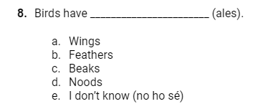

3.4. Procedure

The experimental sessions were organised during the regular class time. The nature of the experiment remained undisclosed to all participants, and the teacher refrained from offering any supplementary practice on vocabulary. Prior to treatment, a training/pilot session with the eye-tracker was conducted in class, so that young learners could be familiarized with the innovative technology. A short musical video from the Charlie and Lola franchise was selected, namely “Bat Cat.” The eye-tracker was calibrated using a 5-point calibration. Participants’ eye-movements were recorded using Tobii T120 (Tobii, www.tobii.com), which is a desktop eye-tracker with the camera and infrared light integrated in the monitor, with a sampling rate of 120 Hz. Visual and auditory input was displayed using Tobii Studio (v3.2.3).
After piloting the eye-tracker, the participants completed a background questionnaire and took the vocabulary pre-test and the EFL picture vocabulary test (see Table 2). Afterwards, participants watched one episode (which lasted approx. 10 minutes) per class, twice a week, with either regular or enhanced captions. After episode 11, participants took the post-test.
Table 2. Experimental procedure
Session 1 |  | Session 2 |  | Session 3 |  | Session 4 |  | Session 5 & 6
Eye-tracker pilot |  | Background information questionnaire |  | Form recall and form recognition pre-tests |  | EFL Picture Vocabulary Test |  | Episodes 1 to 2
 | Session 7 |  | Session 8 to 14 |  | Session 15 |  | Session 16
 | Episode 3 with  eye-tracker |  | Episodes 4 to 10 |  | Episode 11 with  eye-tracker |  | Form recall and form recognition post-tests

Episodes 3 and 11 were viewed individually through the eye-tracker. Episode 3 was selected under the assumption that the children would have become somehow acquainted with the viewing experience by that point, and episode 11 was chosen as the final episode for assessing any potential changes resulting from the intervention. Episodes 3 and 11 were analysed on Lextutor (Cobb, 2019) for coverage, tokens, word types, type-token ratio, and lexical density (see Table 3). Both episodes had at least a 90% coverage at K1, compared to the 80% threshold suggested for audiovisual input by Durbahn et al. (2020, 2022), which indicates suitability for low proficiency learners and comparability in terms of vocabulary profile.
Table 3. Vocabulary profile for episodes 3 and 11
Episode | Coverage | Tokens and Types | Type-token ratio | Lexical density
E3: "I must take absolutely everything" | K1: 91.1% | Tokens: 952 | 0.30 | 0.51
E3: "I must take absolutely everything" | K2: 93.9% | Types: 285 | 0.30 | 0.51
E11: "I will be especially, very careful" | K1: 90.6% | Tokens: 1.084 | 0.25 | 0.50
E11: "I will be especially, very careful" | K2: 93.8% | Types: 272 | 0.25 | 0.50

3.5. Data analysis

The software IBM SPPS Statistics 27 version was used for the analyses. First, the normal distribution of scores was assessed and confirmed. Then, an independent samples t-test was conducted to assess the comparability between experimental groups (enhanced and regular captions). Previous vocabulary size as measured by the EFL picture vocabulary test was non-significantly different across both groups (p = .135); see descriptive statistics in Table 4.
Table 4. Descriptive statistics: vocabulary size
 | Vocabulary size (max: 50)
 | Mean | SD | Min | Max
Regular (n = 8) | 26.63 | 9.54 | 16 | 32
Enhanced (n = 9) | 20.33 | 4.50 | 9 | 24
All participants (n = 17) | 23.29 | 7.96 | 9 | 32

3.5.1. Vocabulary Tests
In the form recall pre- and post-tests, one point was given to each 100% accurate response while half a point was awarded to those responses that approached the target form. Form recognition pre- and post-tests, however, were scored dichotomously (0 or 1).

3.5.2. Eye-tracking data
Every target word, either enhanced or unenhanced, was selected as AOI (i.e.: Area of Interest). The AOIs were manually drawn, making sure the space around each word remained the same for all AOIs. The eye-movement measure under analysis was average fixation duration (the mean of the duration for each individual fixation within an AOI, that is, the sum of the duration for all fixations divided by the total fixation count). The percentage of eye-tracking samples correctly identified for participants was set at 70%, and the rest was discarded.

4. Results

The descriptive statistics of the pre-test and post-test scores appear in Table 5, results for each test range from 0 to 1.
Table 5. Descriptive statistics: pre-test, post-test and absolute gains
 | Form recall
 | Pre-test |  | Post-test |  | Absolute gains
 | Mean | SD | Mean | SD | Mean | SD
Regular (n = 8) | 0.29 | 0.39 | 0.39 | 0.43 | 0.10 | 0.14
Enhanced (n = 9) | 0.26 | 0.36 | 0.47 | 0.43 | 0.21 | 0.40
All participants (n = 17) | 0.28 | 0.37 | 0.44 | 0.43 | 0.16 | 0.39
 | Form recognition
 | Pre-test |  | Post-test |  | Absolute gains
 | Mean | SD | Mean | SD | Mean | SD
Regular (n = 8) | 0.48 | 0.50 | 0.53 | 0.50 | 0.05 | 0.43
Enhanced (n = 9) | 0.46 | 0.49 | 0.67 | 0.47 | 0.21 | 0.58
All participants (n = 17) | 0.47 | 0.50 | 0.61 | 0.49 | 0.14 | 0.52

Analyses were conducted separately for form recall and for form recognition using GLMMs with participants as subjects and item and time as repeated measures.

4.1. Vocabulary acquisition through multimodal input

The first research question addressed the effects of viewing the captioned series regardless of experimental condition. For form recall, L2 Vocabulary Knowledge (F (1, 998) = 10.648, p = .001) and Time (F (1, 998) = 59.766, p < .001) emerged as significant main effects in the model (see Table 6).
Table 6. Results from GLMM: fixed coefficients for form recall regardless of experimental group
Model Term | Coefficient | Std. Error | t | Sig. | 95% CI |  |  | Exp (Coeff.) | 95% CI for Exp (Coeff.)
 |  |  |  |  | Lower | Upper |  |  | Lower | Upper
Intercept | -2.467 | .7228 | -3.414 | .001 | -3.886 | -1.049 | .085 |  | .021 | .350
Vocabulary | .092 | .0282 | 3.263 | .001 | .037 | .148 | 1.097 |  | 1.037 | 1.159
Time=1 | -1.109 | .1434 | -7.731 | < .001 | -1.390 | -.827 | .330 |  | .249 | .437
Time=2 | 0^{b} | . | . | . | . | . | . |  | . | .
To calculate the number of words learned, we multiplied the outcome difference between testing times by all 36 target words. In this case, all participants showed an improvement of 8.4 words (23.3%) from pre-test to post-test in form recall (p < .001) (see Figure 2).
Figure 2. Form recall by time
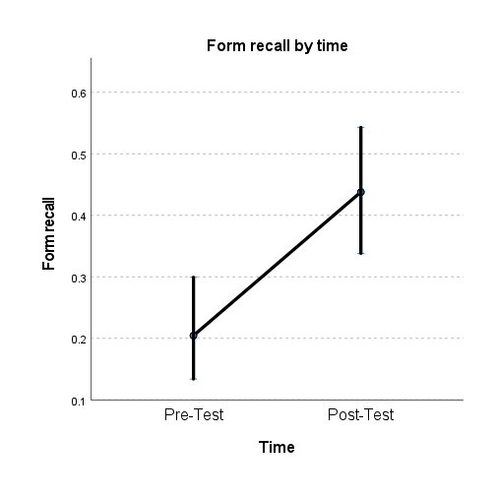

In terms of form recognition, L2 Vocabulary Knowledge (F (1,1289) = 6.973, p = .008) and Time (F (1, 1289) = 27.660, p < .001) also had significant main effects (see Table 7).
Table 7. Results from GLMM: fixed coefficients for form recognition regardless of experimental group

Model Term | Coefficient | Std. Error | t | Sig. | 95% CI |  | Exp (Coeff.) | 95% CI for Exp (Coeff.)
 |  |  |  |  | Lower | Upper | Exp (Coeff.) | Lower | Upper
Intercept | -.986 | .5672 | -1.738 | .082 | -2.099 | .127 | .373 | .123 | 1.135
Vocabulary | .061 | .0232 | 2.641 | .008 | .016 | .107 | 1.063 | 1.016 | 1.113
Time=1 | -.579 | .1100 | -5.259 | < .001 | -.794 | -.363 | .561 | .452 | .696
Time=2 | 0^{b} | . | . | . | . | . | . | . | .

The pairwise comparison (see Figure 3) showed a significant increase of 5.1 words (14.2%) from pre-test to post-test (p < .001).
Figure 3. Form recognition by time
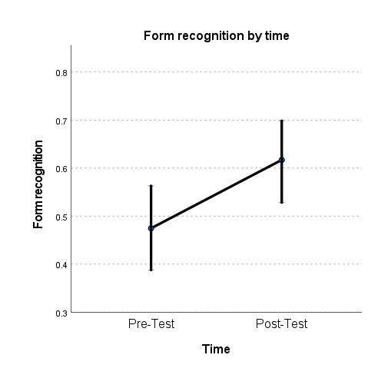

4.2. The effects of textual enhancement

The second research question aimed to investigate the impact of enhanced captions, in comparison to regular captions, on the acquisition of L2 vocabulary. In terms of form recall, significant main effects of L2 Vocabulary Knowledge (F (1, 996) = 10.704, p = .001), and Time (F (1, 996) = 54.909, p < .001) and a significant interaction between Experimental Group and Time (F (1, 996) = 6.050, p = .014) were found in the analyses, as well as a non-significant main effect of Experimental Group (F (1, 996) = 1.213 p = .271) (see Table 8).
Table 8. Results from GLMM: fixed coefficients for form recall
Model Term | Coefficient | Std. Error | t | Sig. | 95% CI |  | Exp (Coeff.) | 95% CI for Exp (Coeff.)
 |  |  |  |  | Lower | Upper | Exp (Coeff.) | Lower | Upper
Intercept | -2.338 | .7300 | -3.202 | .001 | -3.770 | -.905 | .097 | .023 | .405
Vocabulary | .100 | .0305 | 3.272 | .001 | .040 | .160 | 1.105 | 1.041 | 1.173
Time=1 | -1.421 | .1957 | -7.261 | < .001 | -1.805 | -1.037 | .242 | .165 | .355
Time=2 | 0^{b} | . | . | . | . | . | . | . | .
Exp_Group=1 | -.895 | .4774 | -1.875 | .061 | -1.832 | .042 | .409 | .160 | 1.043
Exp_Group=2 | 0^{b} | . | . | . | . | . | . | . | .
[Exp_Group=1]*[Time=1] | .694 | .2823 | 2.460 | .014 | .140 | 1.248 | 2.003 | 1.151 | 3.485
[Exp_Group=2]*[Time=1] | 0^{b} | . | . | . | . | . | . | . | .
[Exp_Group=1]*[Time=2] | 0^{b} | . | . | . | . | . | . | . | .
[Exp_Group=2]*[Time=2] | 0^{b} | . | . | . | . | . | . | . | .

There was a significant increase from pre-test to post-test for both groups: for RC (p = .001) of 4.7 words (12.9%), and for EC (p < .001) of 11.2 words, (31.1%). Even though comparisons at pre-test were non-significant between the two groups (p = .715) the pairwise contrasts showed significant differences between both groups at post-test, where knowledge in the post-test was significantly higher for the EC group (p = .050) (see Figure 4).
Figure 4. Form recall by time by experimental group
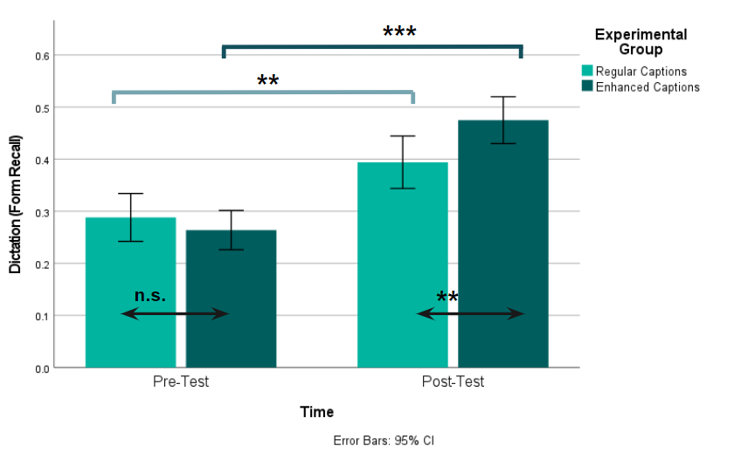
n.s. → p > .05
** → p < .05
*** → p < .001
For form recognition, we found significant main effects of L2 Vocabulary Knowledge (F (1, 1287) = 9.572, p = .002), and Time (F (1, 1287) = 22.710, p < .001) and a significant interaction between Experimental Group and Time (F (1, 1287) = 7.630, p = .006), as well as a non-significant main effect of Experimental Group (F (1, 1287) = 3.015 p = .083) (see Table 9).
Table 9. Results from GLMM: fixed coefficients for form recognition
Model Term | Coefficient | Std. Error | t | Sig. | 95% CI |  | Exp (Coeff.) | 95% CI for Exp (Coeff.)
 |  |  |  |  | Lower | Upper | Exp (Coeff.) | Lower | Upper
Intercept | -.837 | .5527 | -1.514 | .130 | -1.921 | .247 | .433 | .146 | 1.281
Vocabulary | .072 | .0234 | 3.094 | .002 | .026 | .118 | 1.075 | 1.027 | 1.125
Time=1 | -.852 | .1511 | -5.639 | < .001 | -1.149 | -.556 | .426 | .317 | .574
Time=2 | 0^{b} | . | . | . | . | . | . | . | .
Exp_Group=1 | -.936 | .3813 | -2.454 | .014 | -1.684 | -.188 | .392 | .186 | .829
Exp_Group=2 | 0^{b} | . | . | . | . | . | . | . | .
[Exp_Group=1]*[Time=1] | .624 | .2259 | 2.762 | .006 | .181 | 1.067 | 1.866 | 1.198 | 2.907
[Exp_Group=2]*[Time=1] | 0^{b} | . | . | . | . | . | . | . | .
[Exp_Group=1]*[Time=2] | 0^{b} | . | . | . | . | . | . | . | .
[Exp_Group=2]*[Time=2] | 0^{b} | . | . | . | . | . | . | . | .

Between-group differences were non-significant at pre-test (p = .399), whereas they were significant at post-test (p = .012) (see Figure 5). Pairwise comparisons between groups displayed significant differences between testing times exclusively for the EC group (p < .001), with an increase of 7.1 words (19.9%) from pre-test to post-test. Whereas RC’s increase of 2.1 words (5.7%) resulted non-significant (p = .175).¹
Figure 5. Form recognition by time by experimental group
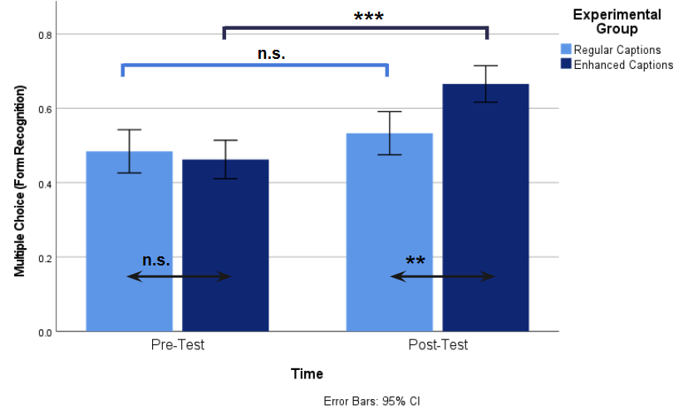
n.s. → p > .05
** → p < .05
*** → p < .001

4.3. Attention behaviour at two times

The third research question asked whether there was a change in viewing behaviour in terms of attention from episode 3 to episode 11 and whether input enhancement drew learners’ visual attention to the target words differently. The analysis was exploratory due to the limited number of target words in each episode and the fact that some words had been already seen in previous episodes (see Table 10).²
Table 10. Frequency of target words per episode
Episode 3 |  |  | Episode 11
Target word | Before | In the episode | Target word | Before | In the episode
Fairy | 14 | 4 | Careful | 3 | 3
Mermaid | 2 | 1 | Fluffy | 0 | 18
Slipper | 0 | 3 | Handbag | 0 | 7
Stripy | 0 | 3 | Kitten | 2 | 1
Suitcase | 0 | 4 | Mud | 2 | 1
Track | 2 | 5 | Pleased | 5 | 1
Wand | 0 | 5 | Shell | 0 | 6
Wings | 0 | 1 | Sticky | 1 | 3
 |  |  | Trolley | 0 | 4

The descriptive data for the eye-tracking metrics is displayed in Table 11. We decided to exclude the target word “fluffy” from our analyses due to its outlier occurrence in episode 11 (18 repetitions) and the word “fairy” due to its high frequency of occurrence prior to episode 3 (14 repetitions) to prevent potential effect of familiarity with this word on participants’ viewing behaviour. After their removal, the range of occurrence of target words in these two episodes was 1 to 7 (M = 3.25; SD = 1.88).
Table 11: Descriptives for the eye-tracking metrics (ms)
 | Average Fixation Duration
 | Episode 3 |  |  |  | Episode 11
 | M | SD | Min | Max |  | M | SD | Min | Max
All participants (n = 17) | 267.5 | 186.2 | 0.0 | 1149.2 |  | 247.6 | 112.7 | 0.0 | 618.0
Regular Captions (n = 8) | 224.0 | 191.6 | 0.0 | 1149.0 |  | 237.7 | 67.7 | 83.0 | 298.0
Enhanced Captions (n = 9) | 311.0 | 171.0 | 0.0 | 1032.0 |  | 255.1 | 137.2 | 0.0 | 618.0

As the data for average fixation duration was not normally distributed, the variable was log transformed. To analyse the eye movements in both episodes, we conducted a GLMM with the eye-tracking metrics as outcome variable. The analysis showed that there was no significant main effect of Frequency on average fixation duration (p = .249). There was a significant effect of Episode (3 vs 11) (F (1, 223) = 11.933 p < .001) but the interaction between Experimental Group and Episode did not reach significance (F (1, 223) = 1.514 p = .072). Moreover, Experimental Group did not show a significant main effect (F (1, 223) = .960 p = .328) (see Table 12).
Table 12. Results from GLMM: fixed coefficients for ln (fixation average)
Model Term | Coefficient | Std. Error | t | Sig. | 95% Confidence Interval
 |  |  |  |  | Lower | Upper
Intercept | -1.526 | .0951 | -16.052 | < .001 | -1.713 | -1.339
Frequency | .017 | .0143 | 1.157 | .249 | -.012 | .045
Episode=3 | .268 | .0808 | 3.313 | < .001 | .108 | .427
Episode=11 | 0^{b} | . | . | . | . | .
Exp_Group=1 | -.032 | .1239 | -.259 | .796 | -.276 | .212
Exp_Group=2 | 0^{b} | . | . | . | . | .
[Exp_Group=1]*[Episode=3] | -.141 | .1143 | -1.231 | .072 | -.366 | .085
[Exp_Group=2]*[Episode=3] | 0^{b} | . | . | . | . | .
[Exp_Group=1]*[Episode=11] | 0^{b} | . | . | . | . | .
[Exp_Group=2]*[Episode=11] | 0^{b} | . | . | . | . | .

A pairwise comparison (see Figure 6), shows that average fixation is significantly higher in episode 3 for the EC group (p = .049), and this difference disappears by episode 11 (p = .796). Moreover, the EC group decreases their average fixation time significantly (p < .001). In the case of RC, however, their average fixation does not change significantly (p = .117) between the two episodes.
Figure 6. Fixation average (s) by episode
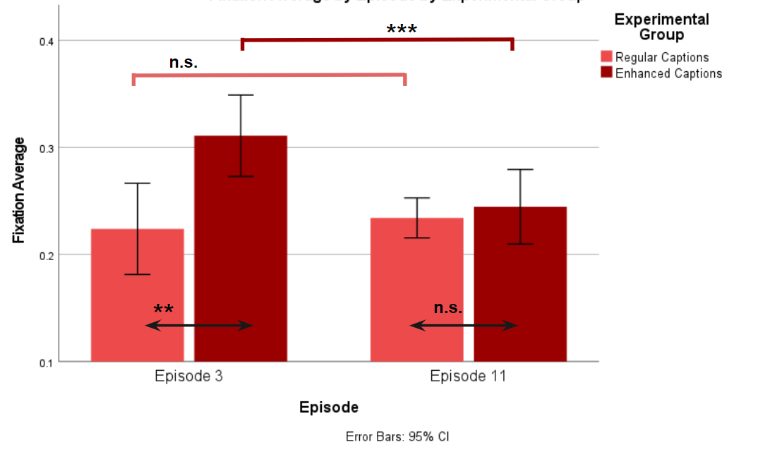
n.s. → p > .05
** → p < .05
*** → p < .001

5. Discussion

The present study is, to our knowledge, the first extensive viewing intervention with young learners to explore the extent to which audiovisual materials with textually enhanced or regular captions promote incidental vocabulary learning. The study also explores the changes in children’s viewing behaviour over the intervention period, providing further insights into the dynamics of young learners’ attention to textually enhanced and regular captions.
The first research question asked whether the viewing of 11 episodes of a captioned cartoon series would result in incidental vocabulary acquisition among fifth graders, as assessed through form recall and form recognition tests. The results showed that the viewing of these episodes led to a significant increase in vocabulary knowledge across all participants, impacting both form recall and form recognition. The number of learned words was modest, as has been previously observed in situations where learning occurs in incidental conditions, but higher than the 7% average found in viewing studies of older and more proficient participants (see Webb et al., 2023). Moreover, other words that were not target items may also have been learned to some degree, as argued by Webb and colleagues (2023). Additionally, the results revealed a significant main effect of previous vocabulary knowledge for both tests, which is in accord with many previous studies (e.g., Feng & Webb, 2020; Montero Perez, 2020; Pattemore & Muñoz, 2022; Peters & Webb, 2018; Pujadas & Muñoz, 2019). This common finding highlights the importance of considering individual differences in vocabulary proficiency when evaluating the impact of audiovisual materials on language learning outcomes. Our results align with previous research that underscores the advantages of incorporating captioned videos in language learning contexts (e.g., Gesa & Miralpeix, 2023; Montero Perez et al., 2013; Reynolds et al., 2022) and confirms the extension of these benefits to younger learners in more or less incidental conditions (Avello & Muñoz, 2023).
In regard to the second research question, we examined differences between the two conditions, enhanced and regular captions. Between-group differences were found to be non-significant in both pre-tests. For both, form recall and form recognition, in addition to the significant effect of previous vocabulary knowledge, there arose a significant interaction between group and time. This indicated that the impact of using textually enhanced captions or regular captions was different in the post-tests. Regarding the regular captions group, results showed a statistically significant increase only for form recall, which was slightly lower than in Avello’s study (8.3% vs 11.1%), but not for form recognition. This result partly differs from Avello’s (2023) result, in that the fifth graders in her study showed a significant advantage with regular captions also in form recognition. An explanation for their higher gains, despite the fact that their prior receptive vocabulary knowledge was slightly lower (M=20.5 vs. M=26.4), could lie in the inclusion of after-viewing tasks in the intervention, which may have increased learners’ attention to the videos. Also, in the present study, both form recall and form recognition tests were administered on the same day, which may have affected participants’ capacity on the second test. On the other hand, the enhanced captions group in our study showed a significant increase in both form recall and form recognition, similar to Avello’s participants. It may be suggested that post-viewing tasks in one study and caption enhancement in the other had analogous effects, increasing learners’ attention to unknown words. In sum, in the current study, the use of enhanced captions proved to be more efficient than the use of regular captions, as evidenced by the significant improvements in both recall and recognition compared to regular captions. This is in line with research that suggests that textual enhancement might have a positive impact on L2 learning (Choi, 2023; Lee & Révész, 2018; 2020; Puimège et al., 2022).
Finally, to address the third, exploratory, research question, we examined whether there was a change in viewing behaviour from soon after the beginning (episode 3) to the end of the intervention (episode 11), and whether this behaviour was different in the two groups. Although the findings are preliminary because the effect of the different target words in the two episodes could not be totally controlled, the analysis of the eye-tracking data indicated significantly longer fixations at the beginning than at the end. However, looking at the two participant groups separately revealed that in episode 3 the EC group exhibited a significantly higher average fixation duration than the RC group, and that in episode 11 this difference had disappeared. The higher average fixation observed when participants engaged with enhanced captions is in general accordance with previous results (e.g., Montero Perez et al., 2015; Puimège et al., 2022). On the other hand, the result that the effect of enhancement diminished over time has not been previously observed in this line of research, the likely reason being that eye-tracking studies have generally taken place in one session and could not examine the effect of habituation on participants’ viewing behaviour. An exception could have been the study by Lee and Révész (2018), in which eye-tracking data was collected in two days over the span of one week, but the researchers did not compare between the groups, enhanced or regular captions, and two short sessions might not have been long enough for potential differences to emerge. Interestingly, in a study addressing the effects of frequency and enhancement in university students’ learning of formulaic sequences through reading, Northbrook et al. (2022) found a short-lived effect of textual enhancement, but the multiple exposures to the target sequences seemingly cancelled out the effect of enhancement. The researchers went on to suggest that enhancement primarily influences the formation of initial memory traces, whereas repetition may affect long-term retention. While more research that occurs over a span of several sessions/weeks is needed to confirm the hypothesis that the effect of enhancement on reading behaviour may be transitory, the finding by Northbrook and colleagues with university students suggests that the phenomenon may not be exclusively associated to young age.

6. Conclusion

In this study, enhanced captions exhibited greater effectiveness in promoting incidental vocabulary acquisition than regular captions. Thus, the use of enhanced captions emerges as a valuable strategy for enhancing the incidental learning of new L2 vocabulary among primary school learners as well, a population that is still understudied in the area of incidental vocabulary learning (Webb et al., 2023) and in viewing studies specifically. Moreover, by means of an eye-tracking analysis, this study suggested that the learners’ attention levels to enhanced captions were higher towards the beginning of the intervention to diminish by the end, eventually approaching the attention levels observed with regular captions. This preliminary finding opens new avenues for research in the areas of captioned viewing and reading.
Nonetheless, this study should be considered in light of some limitations. First of all, the relatively small sample size may impact the generalizability of our findings and the results should be interpreted with caution. This small sample prevented us from counterbalancing episodes so that half of the participants watched episode 3 first and the other half watched episode 11 first to avoid having confounding episode-related variables across the comparison, as suggested by a reviewer. Another shortcoming is the limited quality of the eye-tracking data from young learners, leading to a 70% threshold and subsequent data loss. Future research is needed that confirms the decline of attention to enhanced captions, as measured by the eye-tracking methodology as well as by participants’ own accounts. Similarly, future studies could investigate how attention patterns relate to language acquisition outcomes by comparing groups watching episodes with and without captions. On another note, the lack of a no-treatment control group limited understanding of potential testing effects, as performance might be influenced by factors beyond exposure to television. Moreover, administering both recall and recognition tests in one session raises concerns about testing effects; a split-testing approach could address this. To finish, although target item frequency did not emerge as significant, this could be due to their low exposure in the non-manipulated TV series or their varied distribution across episodes. However, the interplay between item frequency and textual enhancement appears as a potentially worthwhile enquiry (see Northbrook et al., 2022) for future viewing studies. Pedagogically, our findings imply that incorporating textual enhancements in captions can be a beneficial strategy for improving L2 vocabulary learning in primary school students. In this sense, primary school educators may find value in integrating enhanced captions in the videos used in language learning activities.

Acknowledgement
Aquest ha estat possible gràcies al suport del programa predoctoral Joan Oró de la Secretaria d’Universitats i Recerca del Departament de Recerca i Universitats de la Generalitat de Catalunya (2023 FI-1 00629), el qual està cofinançat per la Unió Europea. This study has also had the support of the research project PID2019-110594. We wish to express our sincere gratitude to Dr Daniela Avello for her invaluable assistance and provision of experimental materials.

Endnotes:
1 A complementary analysis based on relative gains (see Horst et al., 1988) confirmed these findings. Two independent samples t-tests showed that EC’s relative gains were higher than RC’s in both form recall (p = .002) and form recognition (p < .001).
2 When conducting a separate analysis controlling target words that were previously seen (by maintaining only those that appear in each episode), results show similar viewing behaviours.

References
Anthony, L., & Nation, I.S.P. (2017). Picture Vocabulary Size Test (version 1.2.0) [Computer software and measurement instrument]. Tokyo, Japan: Waseda University. http://www.laurenceanthony.net/software/pvst
Avello, D. (2023). L2 learning from captioned-video viewing in primary school students. [Unpublished doctoral dissertation, University of Barcelona].
Avello, D., & Muñoz, C. (2023). The Development of Receptive Language Skills from Captioned Video Viewing in Primary School EFL Learners. Education Sciences, 13(5), 479. https://doi.org/10.3390/educsci13050479
Carrington, M., & Child, L. (Executive producers). (2005-2008). Charlie and Lola [Animated TV series]. Tiger Aspects Productions.
Choi, S. (2023). Visual saliency in captioned digital videos and learning of English collocations: An eye-tracking study. Language Learning & Technology, 27(1), 1–21. https://hdl.handle.net/10125/73536
de Vos, J.F., Schriefers, H., Nivard, M.G. and Lemhöfer, K. (2018), A Meta-Analysis and Meta-Regression of Incidental Second Language Word Learning from Spoken Input. Language Learning, 68, 906-941. https://doi.org/10.1111/lang.12296
Feng, Y., & Webb, S. (2020). Learning vocabulary through reading, listening, and viewing: which mode of input is most effective? Studies in Second Language Acquisition, 42(3), 499–523. http://doi.org/10.1017/S0272263119000494
Gesa, F., & Miralpeix, I. (2023). Extensive viewing as additional input for foreign language vocabulary learning: A longitudinal study in secondary school. Language Teaching Research, 0(0). https://doi.org/10.1177/13621688231169451
Horst, M., Cobb, T., & Meara, P. (1998). Beyond a Clockwork Orange: Acquiring Second Language Vocabulary through Reading. Reading in a Foreign Language, 11, 207-223.
Lee, S. K. (2007). Effects of textual enhancement and topic familiarity on Korean EFL students’ reading comprehension and learning of passive form. Language Learning, 57(1), 87–118. https://doi.org/10.1111/j.1467-9922.2007.00400.x
Lee, M., & Révész, A. (2018). Promoting Grammatical Development Through Textually Enhanced Captions: An Eye-Tracking Study. The Modern Language Journal, 102(3), 557–577. https://doi.org/10.1111/modl.12503
Lee, M., & Révész, A. (2020). Promoting grammatical development through captions and textual enhancement in multimodal input-based tasks. Studies in Second Language Acquisition, 42(3), 1–27. https://doi.org/10.1017/S0272263120000108
Leow, R.P., & Martin, A. (2017). Enhancing the Input to Promote Salience of the L2. A Critical Overview. Routledge.
Montero Perez, M. (2020). Incidental vocabulary learning through viewing video. The role of vocabulary knowledge and working memory. Studies in Second Language Acquisition, 42(4), 749–773. https://doi.org/10.1017/S0272263119000706
Montero Perez, M. (2022). Second or foreign language learning through watching audio-visual input and the role of on-screen text. Language Teaching, 55(2), 163-192. https://doi.org/10.1017/S0261444821000501
Montero Perez, M., Peters, E., & Desmet, P. (2015). Enhancing vocabulary learning through captioned video: An eye‐tracking study. The Modern Language Journal, 99, 308–328. https://doi.org/10.1111/modl.12215
Montero Perez, M., Van Den Noortgate, W., & Desmet, P. (2013). Captioned video for L2 listening and vocabulary learning: A meta-analysis. System, 41(3), 720–739. https://doi.org/10.1016/j.system.2013.07.013
Muñoz, C. (2017). The role of age and proficiency in subtitle reading. An eye-tracking study. System, 67, 77–86. https://doi.org/10.1016/j.system.2017.04.015
Muñoz, C. (2022). Audiovisual input in L2 learning. Language, Interaction and Acquisition. 13(1): 125-143. https://doi.org/10.1075/lia.22001.mun.
Northbrook, J., Allen, D., & Conklin, K. (2022). ‘Did You See That?’—The Role of Repetition and Enhancement on Lexical Bundle Processing in English Learning Materials. Applied Linguistics, 43(3), 453-472. https://doi.org/10.1093/applin/amab063
Pattemore, A., & Muñoz, C. (2022). Captions and learnability factors in learning grammar from audio-visual input. The JALT CALL Journal, 18(1), 83-109. https://doi.org/10.29140/jaltcall.v18n1.564
Pellicer-Sánchez, A., Tragant, E., Conklin, K., Rodgers, M., Serrano, R., & Llanes, À. (2020). Young learners’ processing of multimodal input and its impact on reading comprehension: An eye-tracking study. Studies in Second Language Acquisition, 42(3), 577–598. https://doi.org/10.1017/S0272263120000091
Peters, E., & Muñoz, C. (2020). Introduction to the special issue. Language learning from multimodal input. Studies in Second Language Acquisition, 42, 489-497. https://doi.org/10.1017/S0272263120000212
Peters, E., & Webb, S. (2018). Incidental vocabulary acquisition through viewing L2 television and factors that affect learning. Studies in Second Language Acquisition, 40(3), 551–577. https://doi.org/10.1017/S0272263117000407
Puimège, E., Montero Perez, M., & Peters, E. (2022). Promoting L2 acquisition of multiword units through textually enhanced audiovisual input: an eye-tracking study. Second Language Research, 39. https://doi.org/10.1177/02676583211049741
Puimège, E., & Peters, E. (2019). Learning L2 vocabulary from audiovisual input: an exploratory study into incidental learning of single words and formulaic sequences. Language Learning, 69, 424-438. https://doi.org/10.1080/09571736.2019.1638630
Puimège, E., & Peters, E. (2020). Learning formulaic sequences through viewing L2 television and factors that affect learning. Studies in Second Language Acquisition, 42(3), 525–549. https://doi.org/10.1017/s027226311900055x
Pujadas, G., & Muñoz, C. (2019). Extensive viewing of captioned and subtitled TV series: a study of L2 vocabulary learning by adolescents, The Language Learning Journal, 47(4), 479-496. https://doi-org /10.1080/09571736.2019.1616806
Pujadas, G., & Muñoz, C. (2020). Examining adolescent EFL learners’ TV viewing comprehension through captions and subtitles. Studies in Second Language Acquisition, 42(3), 1–25. https://doi.org/10.1017/S0272263120000042
Reynolds, B.L.; Cui, Y.; Kao, C.-W. and Thomas, N. (2022). Vocabulary Acquisition through Viewing Captioned and Subtitled Video: A Scoping Review and Meta-Analysis. Systems, 10(133). https://doi.org/10.3390/systems10050133
Sharwood Smith, M. (1993). Input enhancement in instructed SLA:Theoretical bases. Studies in Second Language Acquisition, 15, 165–179. https://doi.org/10.1017/S0272263100011943
Serrano, R. & Pellicer‐Sánchez, A. (2019). Young L2 learners’ online processing of information in a graded reader during reading-only and reading-while-listening conditions: A study of eye-movements. Applied Linguistics Review. 13(1). https://doi.org/10.1515/applirev-2018-0102
Tragant, E., & Pellicer-Sánchez, A. (2019). Young EFL learners’ processing of multimodal input: Examining learners’ eye movements. System, 80, 212-223. https://doi.org/10.1016/j.system.2018.12.002
Vanderplank, R. (2016). Captioned media in foreign language learning and teaching: Subtitles for the deaf and hard-of-hearing as tools for language learning. Palgrave Macmillan. https://doi.org/10.1057/978-1-137-50045-8
Winke, P. M. (2013). The effects of input enhancement on grammar learning and comprehension: A modified replication of Lee (2007) with eye-movement data. Studies in Second Language Acquisition, 35(2), 323–352. https://doi.org/10.1017/S0272263112000903
Webb, S., Uchihara, T., & Yanagisawa, A. (2023). How effective is second language incidental vocabulary learning? A meta-analysis. Language Teaching, 56(2), 161–180. http://doi.org/10.1017/S0261444822000507

